Steps to setup GIT user profile:

<https://confluence.devops.lloydsbanking.com/display/ET/4.+Work+with+Git+and+Gerrit>

Link to install GIT bash:

\\appdvstp025\STP Software\Git

\\Global.lloydstsb.com\file\D_COMMON0044$\Shared\Rig Create\SIP - T24\Software

Design studio:

Window 🡪 Open Perspective 🡪 other

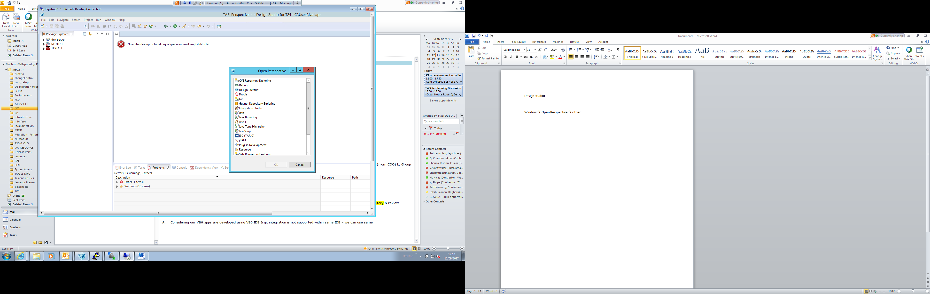

Choose GIT

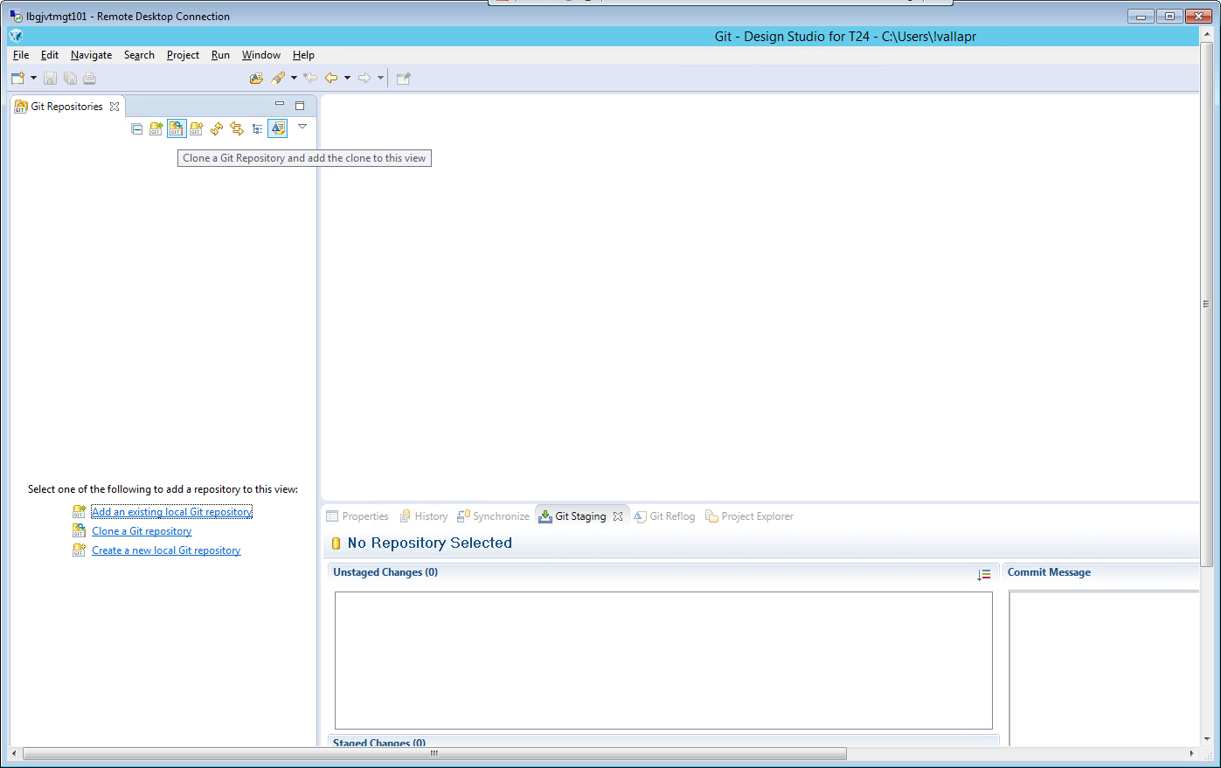

Open this URL in your browser - > <http://10.59.151.120:9100> and click the become icon.

If you above site is not opening please follow the steps show below.

Go to tools in Internet Explorer

Tools🡪compatibility view setting

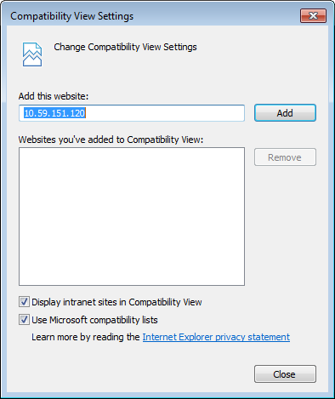

Uncheck the Display intranet sites in Compatibility view and refresh the page.

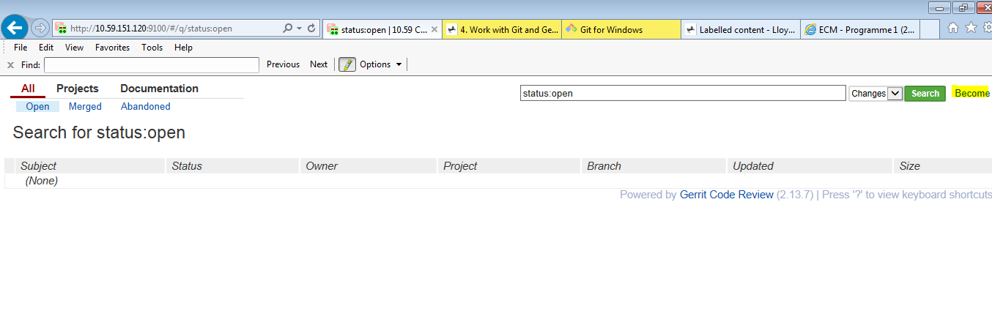

Click the ‘New Account’ button at the end.

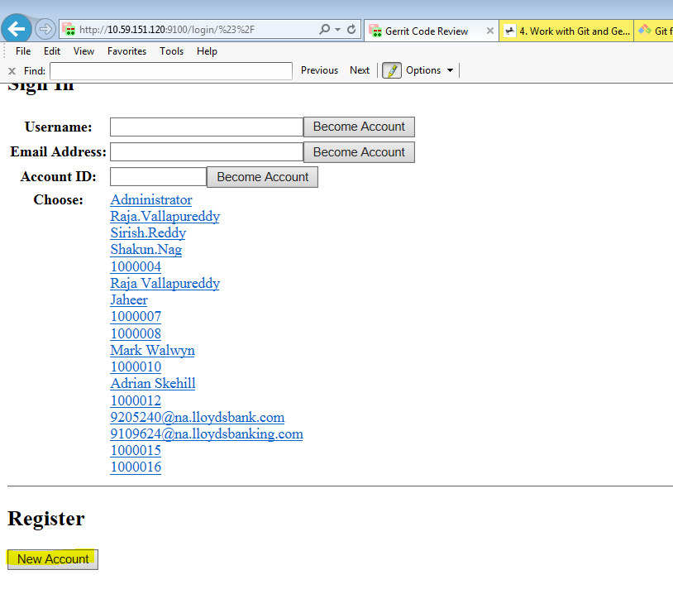

Fill the details here.

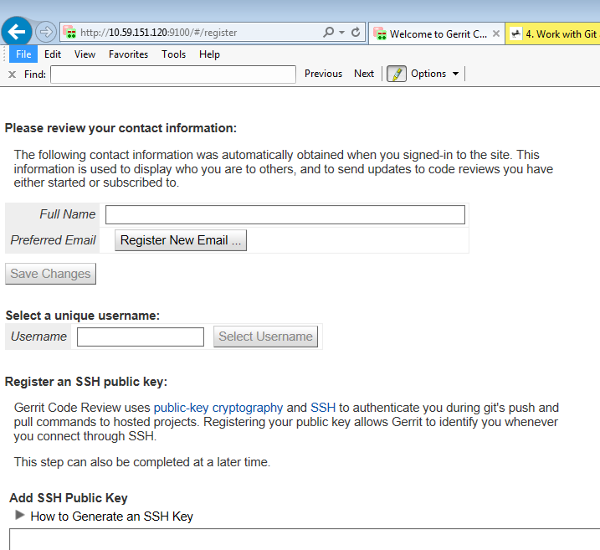

For generating the key use the GIT bash which can be installed from below steps

Go to start->All Programes->Git->Git bash

Now type ssh-keygen

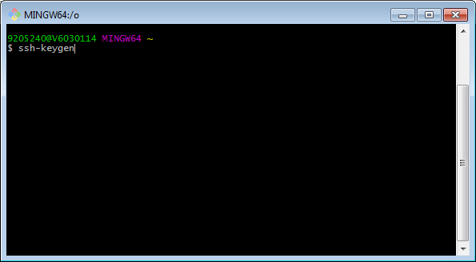

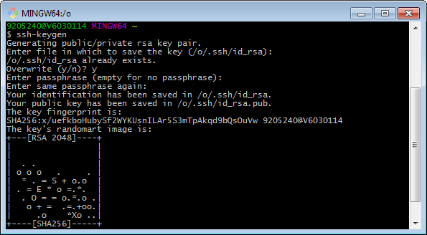

Once the public key is generated please copy the key form the path .ssh/id_rsa.pub by using the cat .ssh/id_rsa.pub command and paste in the below window, and click continue this will complete the user creation.

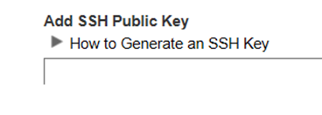

After the user is created now some of the parameter we need to change in design studio

Open design studio navigate to window-> Preferences

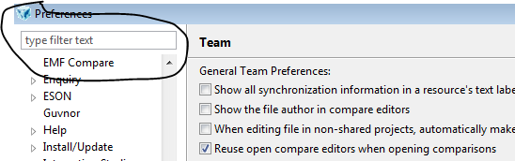

Type ssh

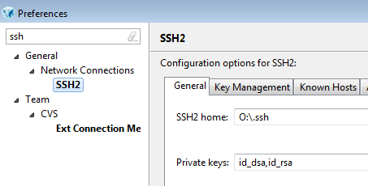

Copy the key path from the shared location and update in SSH2 home:

Please screen shot for the same.

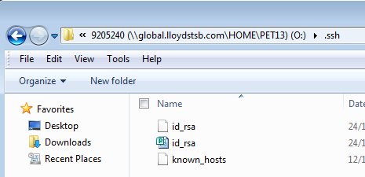

After this we need to add the user details like user name and user email id please find the screen shot for the same.

Git->configuration

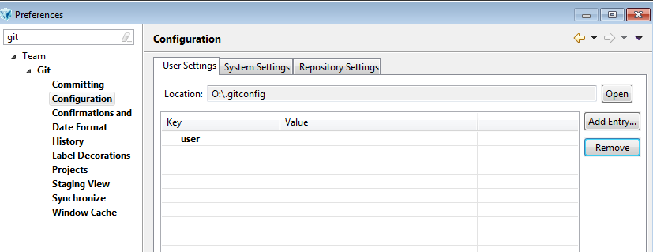

Click on Add entry

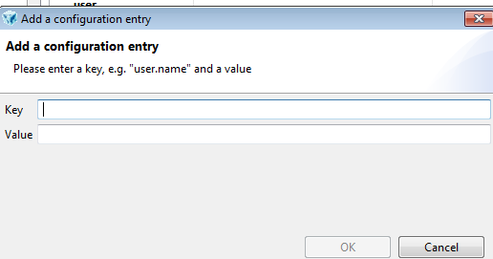

In the key update as user.name and in value update user name created in Gerrit (<http://10.59.151.120:9100>)

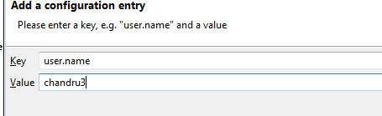

Once done click add entry once again to add the email id.

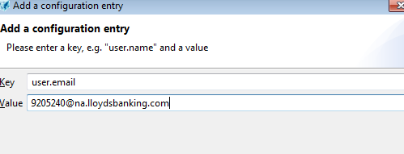

Click on ok to complete the process.

Now we need to clone the git repository.

Once you’re at the home screen of Design studio you can find the clone a git repository(2nd option)

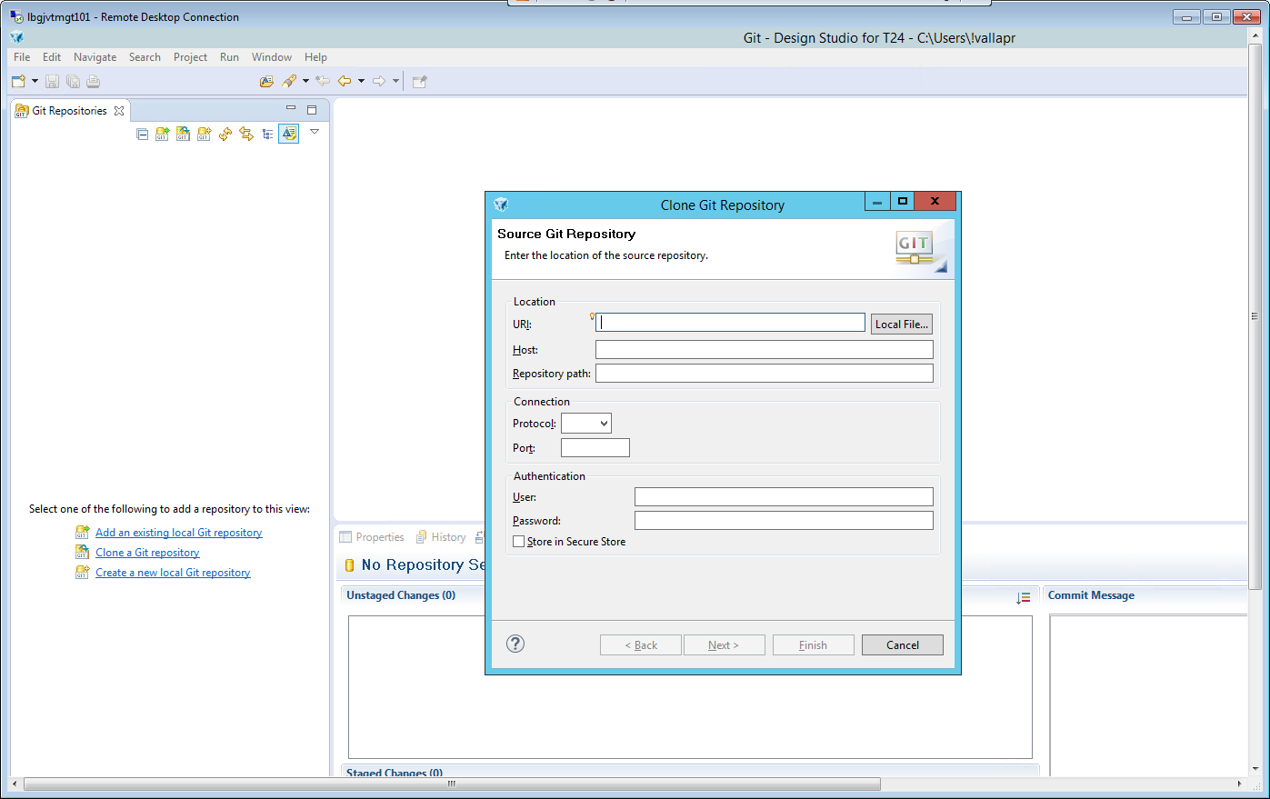

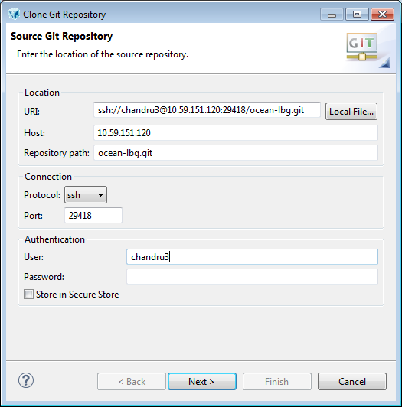

Host:10.59.151.120

Repository path:ocean-lbg.git

Protocol:ssh

Port 29418

User: id create in gerrit

Password: if you have given any password at time of public generation if not given please leave it as blank.

Than click on Next

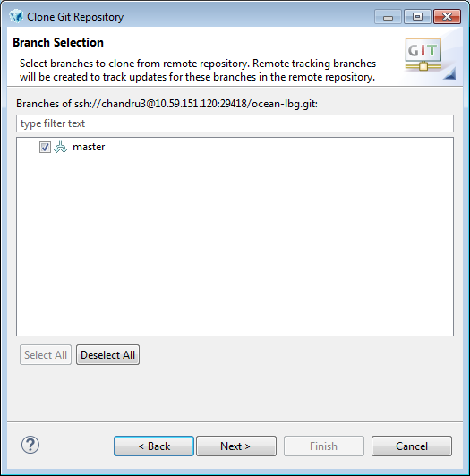

Once all the details are correctly given you can find the above window.

Now click on next

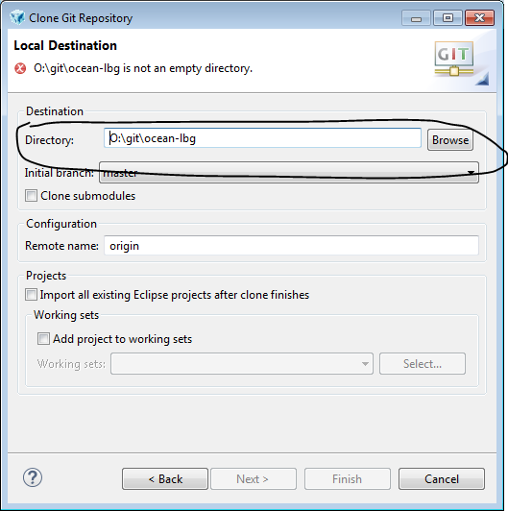

Now it will ask for the directory or folder where local repository has to be dumped, so please create the new directory and provide the path

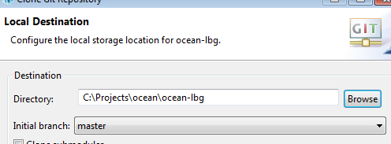

Once done the git will push all the source code to the local drive and you can see the progress.

So these steps will complete the installation, configuring, cloning the GIT

Next we will show how to work with changing the code and how to commit and push to gerrit review.

Once the clone is done you will be able to find the below window.

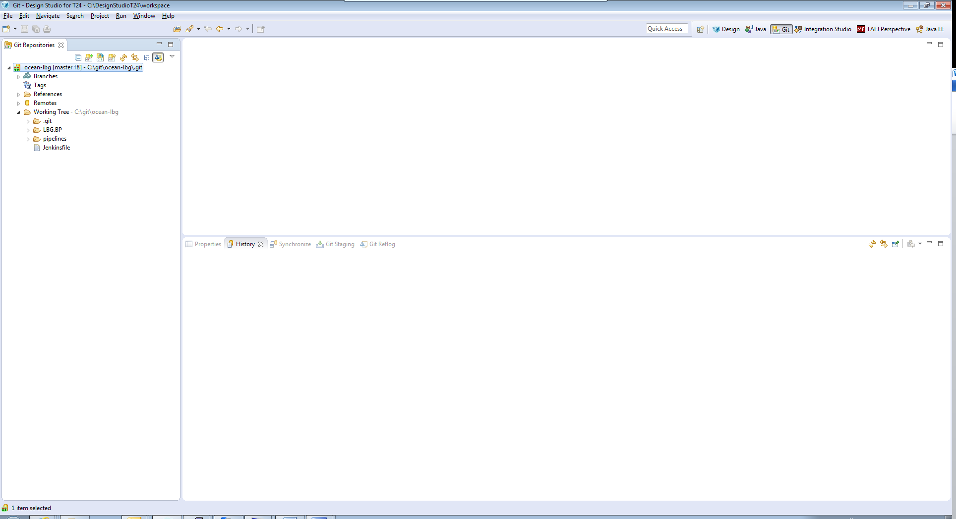

When you modify a program and save it(file->save) its will show in Unstaged changes as below

Now the above screen shows unstaged changes and in commit message you can give any message to identify the change so that you can get the same in gerrit.

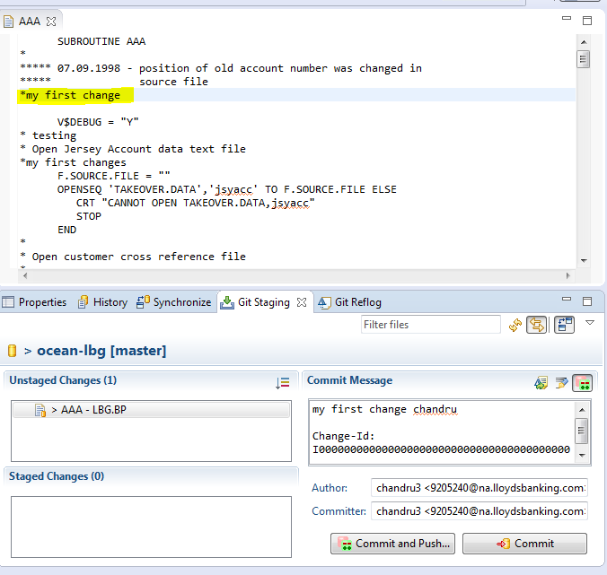

Now drag and drop the file in unstaged changes to staged change

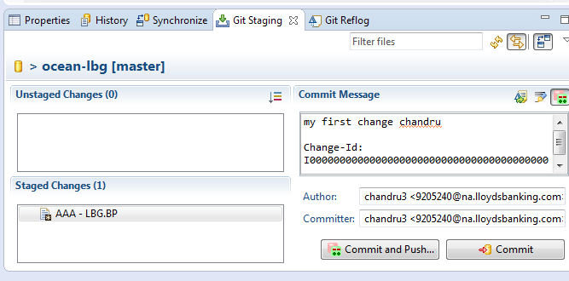

Now commit and push it will trigger a build in gerrit to review.

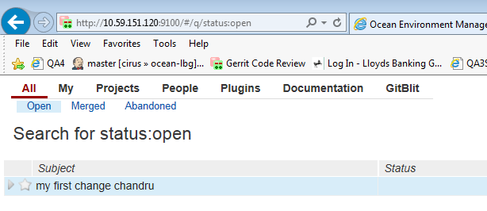

Click on the change and review it and submit if everything well and good or you can reject the change.

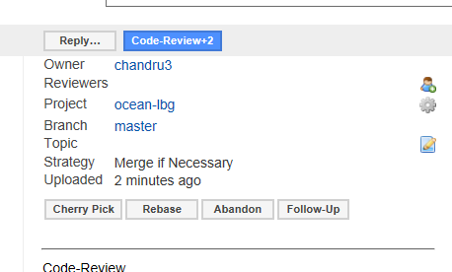

Once the code is reviewed this will build in Jenkins.